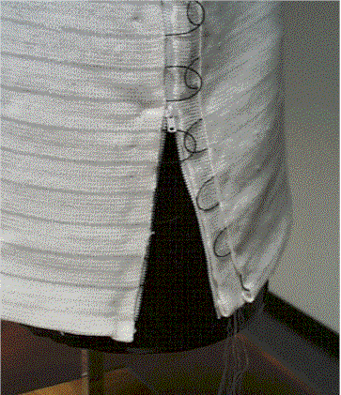
Figure 5. Zipper Attachment on Knitted Wearable Motherboard™

