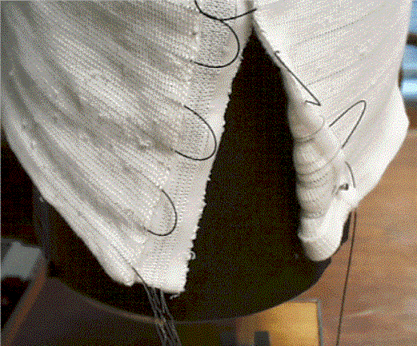
Figure 4. Velcro Attachment on Knitted Wearable Motherboard™

