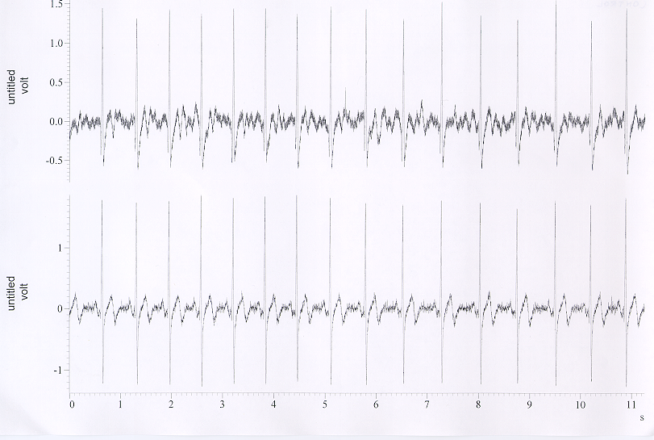
Figure 3. EKG Trace from the Georgia Tech Wearable Motherboard™
EKG from Control
EKG from GTWM

