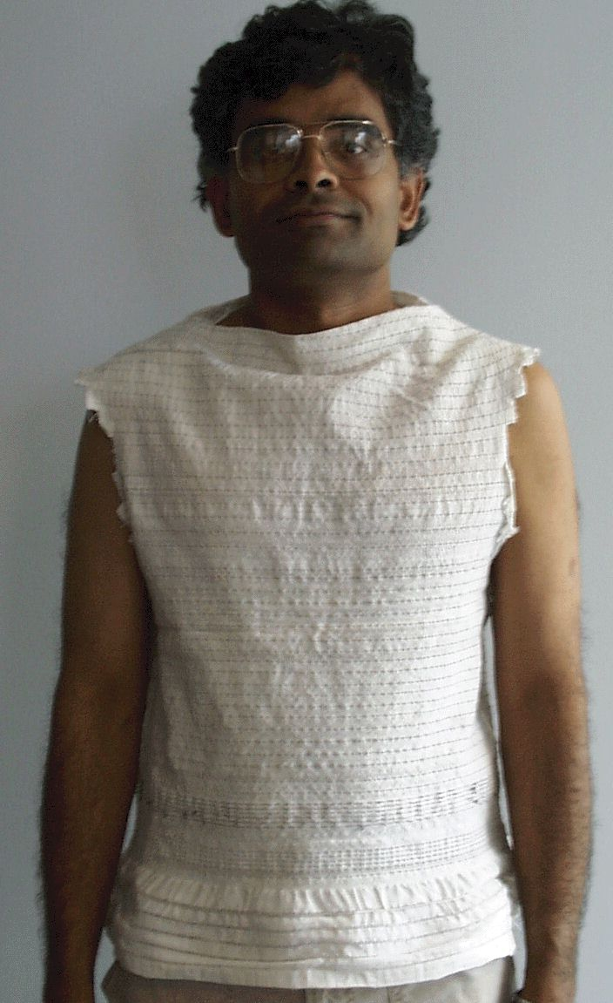
Figure 2. Woven Wearable Motherboard™ on Subject

