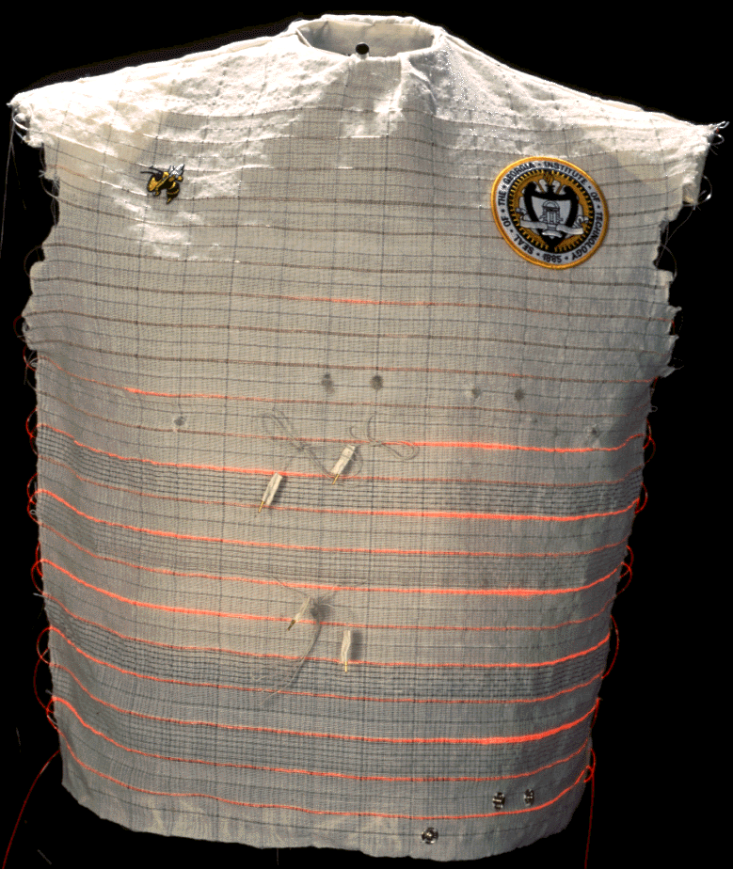
Figure1. Woven Wearable Motherboard™

